Project Review: Customer Based Analysis & Revenue Strategy

1. Project Overview & Objectives
The goal of this internship project was to transform fragmented hotel booking data into a strategic decision-making tool. By analysing three years of historical data from "Google Revenue" files, the dashboard provides a 360-degree view of guest behaviour and revenue drivers.
- Primary Objective: To enable stakeholders (General Managers and Revenue Managers) to monitor KPIs and optimize room occupancy.
- Key Focus Areas: Guest demographics, booking channels, lead time analysis, and seasonal stay trends.

2. Technical Execution (The 4-Step Process)
I followed a rigorous data engineering and analytics workflow to ensure data integrity and performance:

Step 1: Data Collection & Profiling
- Gathered data from hotel booking datasets covering various hotel revenue metrics.
- Performed initial profiling to identify missing dates, duplicate entries, and null values in critical fields like ADR (Average Daily Rate) and arrival date.

Step 2: Data Transformation (Power Query)
- Data Cleaning: Filtered out cancellations (is_canceled = 1) to ensure the dashboard reflects actual stayed revenue.
- Custom Calculations: Created calculated columns for Total Guests (Adults + Children + Babies) and Total Stay (Weekend + Week nights).
- Validation: Standardized country codes and handled null values in the children column to maintain demographic accuracy.

Step 3: Data Modelling (Star Schema)
To optimize filter performance and scalability, I implemented a Star Schema:
- Fact Tables: Fact_Bookings and Fact_Daily_Revenue.
- Dimension Tables: Created lookup tables for Dim_Date, Dim_Customer, and Dim_Hotel.
- Relationships: Established one-to-many relationships with single-direction cross-filtering.

3. Key Insights & Dashboard Highlights

1. High-Level Summary Metrics (KPIs)
These cards provide an immediate snapshot of the total volume and scale of the data being analyzed.
- Total Guests (88K): The aggregate number of individuals across all bookings.
- Sum of Adults (83K): The primary guest demographic, accounting for the vast majority of the population.
- Sum of Children (4,553): Insights into the family-friendliness of the bookings.
- Sum of Babies (310): A niche segment requiring specific amenities (cribs, high chairs).
- Sum of Lead Time (4M): Total days between booking and arrival (indicates booking window trends).
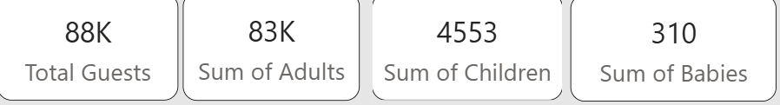

2. Slicers (Filters)
Users can drill down into specific data segments using the following filters located at the top:
- Arrival Year: Filter by specific years to see year-over-year growth.
- Hotel: Currently set to City Hotel (options likely include Resort Hotel).
- Market Segment: Filter by how the room was sold (e.g., Online TA, Offline TA, Corporate).
- Assigned Room Type: Analyze data based on the specific room category assigned.

3. Visualizations & Insights

Repeated Guest by Customer Type
- Visual Type: Horizontal Bar Chart
- Insight: Identifies loyalty among different segments. Transient guests represent the highest volume of repeat business, while Contract and Group segments show significantly lower repeat rates.

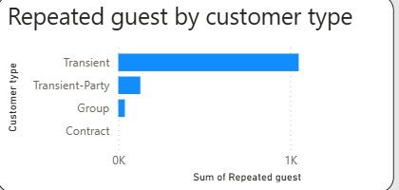

Total Bookings by Distribution Channel
- Visual Type: Pie Chart
- Insight: Dominance of TA/TO (Travel Agents/Tour Operators) at 82.82% (37K bookings). This highlights a heavy reliance on third-party intermediaries compared to Direct (11.23%) or Corporate bookings.
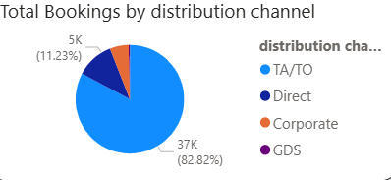

The Length of Stay Trend
- Visual Type: Combo Chart (Bar & Line)
- Insight: Tracks the Sum of Total Nights (Bars) against Total Guests (Line) by month. There is a clear upward trend leading into the summer months (July and August), indicating peak season for both volume and duration of stay.

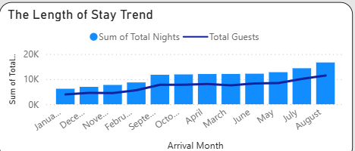

Guest Stay Based on Age
- Visual Type: Donut Chart
- Insight: A demographic breakdown showing that Adults make up 94.47% of the guest population, confirming the hotel's primary appeal to adult travellers rather than families with children (5.18%).
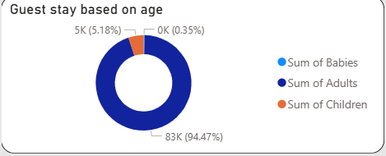

Geographic Breakdown (Table)
- Data Points: Country, Total Guests, Sum of Stays (Week/Weekend nights).
- Insight: Portugal (PRT) and France (FRA) are the top two feeder markets, with PRT having the highest guest count (17,531).
. 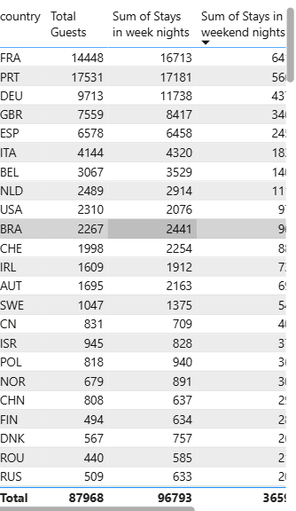

4. Business Recommendations
Based on the data, I propose the following strategies:
- Direct Booking Incentives: Since direct bookings are only ~11%, implementing "Loyalty Member Rates" could reduce TA/TO commission costs.
- Family Packages: With children making up only ~5% of guests, there is an untapped market for family-oriented marketing or amenities to increase weekend occupancy.
- Lead Time Management: Given the 4M total lead time, the hotel can implement "Early Bird" discounts 4–6 months in advance to secure base occupancy early.

5. Future Enhancements
- Predictive Analytics: Integrating a machine learning model to predict the probability of cancellation.
- Dynamic Pricing: Using DAX to create real-time ADR recommendations based on current occupancy levels.

